**ARYAMAN MISHRA**

**19BCE1027**

**LAB 8**

1. **Simple MPI Send and Recv**

#include <mpi.h>

#include <stdio.h>

#include <stdlib.h>

int main(int argc, char** argv) {

// Initialize the MPI environment

MPI_Init(NULL, NULL);

// Find out rank, size

int world_rank;

MPI_Comm_rank(MPI_COMM_WORLD, &world_rank);

int world_size;

MPI_Comm_size(MPI_COMM_WORLD, &world_size);

// We are assuming at least 2 processes for this task

if (world_size < 2) {

fprintf(stderr, "World size must be greater than 1 for %s\n", argv[0]);

MPI_Abort(MPI_COMM_WORLD, 1);

}

int number;

if (world_rank == 0) {

// If we are rank 0, set the number to -1 and send it to process 1

number = -1;

MPI_Send(

/* data = */ &number,

/* count = */ 1,

/* datatype = */ MPI_INT,

/* destination = */ 1,

/* tag = */ 0,

/* communicator = */ MPI_COMM_WORLD);

} else if (world_rank == 1) {

MPI_Recv(

/* data = */ &number,

/* count = */ 1,

/* datatype = */ MPI_INT,

/* source = */ 0,

/* tag = */ 0,

/* communicator = */ MPI_COMM_WORLD,

/* status = */ MPI_STATUS_IGNORE);

printf("Process 1 received number %d from process 0\n", number);

}

MPI_Finalize();

}

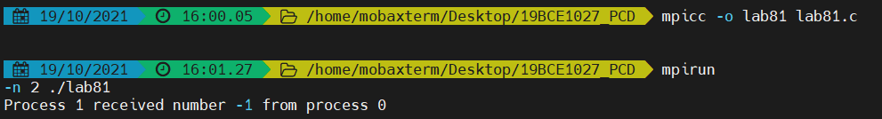

#include <mpi.h>

#include <stdio.h>

#include <stdlib.h>

int main(int argc, char** argv) {

const int PING_PONG_LIMIT = 10;

// Initialize the MPI environment

MPI_Init(NULL, NULL);

// Find out rank, size

int world_rank;

MPI_Comm_rank(MPI_COMM_WORLD, &world_rank);

int world_size;

MPI_Comm_size(MPI_COMM_WORLD, &world_size);

// We are assuming 2 processes for this task

if (world_size != 2) {

fprintf(stderr, "World size must be two for %s\n", argv[0]);

MPI_Abort(MPI_COMM_WORLD, 1);

}

int ping_pong_count = 0;

int partner_rank = (world_rank + 1) % 2;

while (ping_pong_count < PING_PONG_LIMIT) {

if (world_rank == ping_pong_count % 2) {

// Increment the ping pong count before you send it

ping_pong_count++;

MPI_Send(&ping_pong_count, 1, MPI_INT, partner_rank, 0, MPI_COMM_WORLD);

printf("%d sent and incremented ping_pong_count %d to %d\n",

world_rank, ping_pong_count, partner_rank);

} else {

MPI_Recv(&ping_pong_count, 1, MPI_INT, partner_rank, 0, MPI_COMM_WORLD,

MPI_STATUS_IGNORE);

printf("%d received ping_pong_count %d from %d\n",

world_rank, ping_pong_count, partner_rank);

}

}

MPI_Finalize();

}

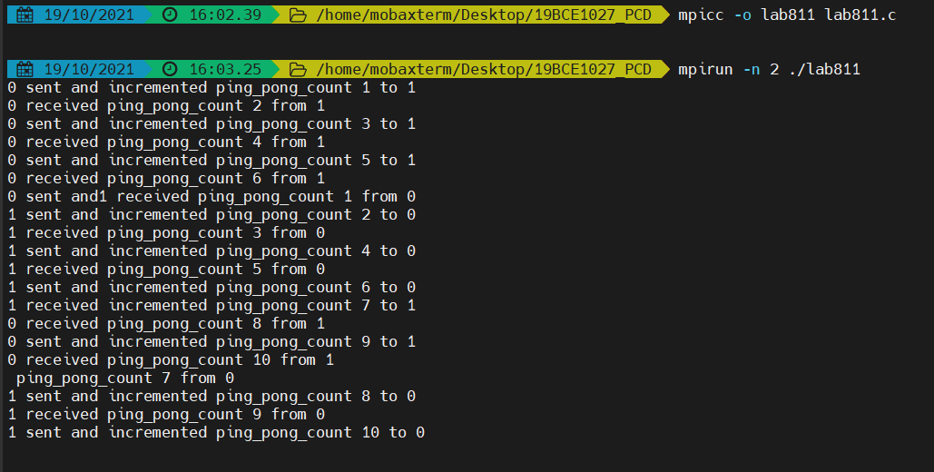

1. **Simple MPI iSend and iRecv**

#include<stdio.h>

#include<stdlib.h>

#include"mpi.h"

//int MPI_Isend(void *buf,int count , MPI_Datatype datatype,int dest , int tag ,MPI_Comm comm,MPI_Request *request);

//int MPI_Irecv(void *buf,int count , MPI_Datatype datatype,int source , int tag , MPI_Comm comm,MPI Request *request)

//int MPI_Wait(MPI_Request *request , MPI_Status *status)

int main(int argc,char* argv[])

{

int numtasks,rank,next,prev,buf[2],tag1=1,tag2=2;

tag1=tag2=0;

MPI_Request reqs[4];

MPI_Status stats[4];

MPI_Init(&argc,&argv);

MPI_Comm_size(MPI_COMM_WORLD,&numtasks);

MPI_Comm_rank(MPI_COMM_WORLD,&rank);

prev=rank-1;

next=rank+1;

if(rank==0)

prev=numtasks-1;

if(rank==numtasks-1)

next=0;

MPI_Irecv(&buf[0],1,MPI_INT,prev,tag1,MPI_COMM_WORLD,&reqs[0]);

MPI_Irecv(&buf[1],1,MPI_INT,prev,tag2,MPI_COMM_WORLD,&reqs[1]);

MPI_Isend(&rank,1,MPI_INT,next,tag2,MPI_COMM_WORLD,&reqs[2]);

MPI_Isend(&rank,1,MPI_INT,next,tag1,MPI_COMM_WORLD,&reqs[3]);

MPI_Waitall(4,reqs,stats);

printf("Task %d communicated with tasks %d & %d\n",rank,prev,next);

MPI_Finalize();

return 0;

}

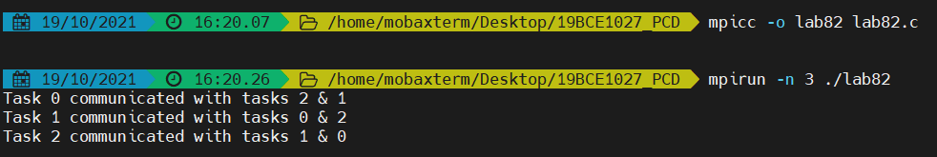

1. **Simple MPI Bcast**

#include <mpi.h>

#include <stdio.h>

int main(int argc, char** argv) {

int rank;

int buf;

const int root=0;

MPI_Init(&argc, &argv);

MPI_Comm_rank(MPI_COMM_WORLD, &rank);

if(rank == root) {

buf = 777;

}

printf("[%d]: Before Bcast, buf is %d\n", rank, buf);

/* everyone calls bcast, data is taken from root and ends up in everyone's buf */

MPI_Bcast(&buf, 1, MPI_INT, root, MPI_COMM_WORLD);

printf("[%d]: After Bcast, buf is %d\n", rank, buf);

MPI_Finalize();

return 0;

}

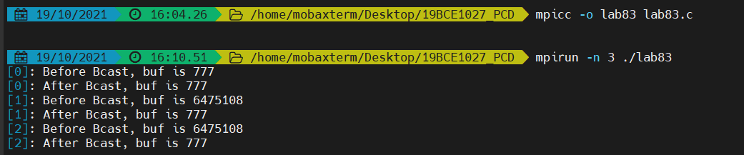

1. **Implementation of Bcast using MPI send and recv**

#include <stdio.h>

#include <stdlib.h>

#include <mpi.h>

void my_bcast(void* data, int count, MPI_Datatype datatype, int root,

MPI_Comm communicator) {

int world_rank;

MPI_Comm_rank(communicator, &world_rank);

int world_size;

MPI_Comm_size(communicator, &world_size);

if (world_rank == root) {

// If we are the root process, send our data to everyone

int i;

for (i = 0; i < world_size; i++) {

if (i != world_rank) {

MPI_Send(data, count, datatype, i, 0, communicator);

}

}

} else {

// If we are a receiver process, receive the data from the root

MPI_Recv(data, count, datatype, root, 0, communicator, MPI_STATUS_IGNORE);

}

}

int main(int argc, char** argv) {

MPI_Init(NULL, NULL);

int world_rank;

MPI_Comm_rank(MPI_COMM_WORLD, &world_rank);

int data;

if (world_rank == 0) {

data = 100;

printf("Process 0 broadcasting data %d\n", data);

my_bcast(&data, 1, MPI_INT, 0, MPI_COMM_WORLD);

} else {

my_bcast(&data, 1, MPI_INT, 0, MPI_COMM_WORLD);

printf("Process %d received data %d from root process\n", world_rank, data);

}

MPI_Finalize();

}

